**Bot** “Extraction of News and Displaying it in Excel”.

**Problem Statement** Difficulty in knowing the latest news.

* People will be aware of the latest news ongoing at any time. Every time the bot run, it will collect the data from the internet, displaying it on screen and meanwhile save it in excel also.

**Activities used in our project are listed below**

* Open Browser: It is used to open any browser.
* Data Scraping: This activity is used to scrap data from the news section along with news headlines.
* Excel Application Scope: This activity is used to read data using the read range.
* Read Range: Read range activity is used to read a table from an excel file from a user-based location.
* Write Range: A data table containing information can be written into an excel file using this activity. The output range of this activity can also be specified inside the “Range” property empty makes the activity write the information from the beginning of a file.
* Send SMTP Mail Message: This activity package is designed to facilitate the automation of any mail-related tasks, covering various protocols, such as IMAP, POP3 or SMTP. UiPath also features activities that are specialized for working with Outlook and Exchange.

**Aim**: To design a bot in UiPath Studio to collect data from news websites.

**Process:**

* Open UiPath Studio, create a process and open the main workflow.
* Drag and drop Open Browser activity to open google. In this do sequence use Data Scraping and the bot will scrap the data using the Write Range activity.
* Use another Excel Application Scope and provide the URL of a blank excel sheet to store the scrapped data using the Write Range activity.
* Use another Excel application scope to read the data using Read Range and store the output in the variable suppose dt of type string and change its scope to the sequence.
* Use Send SMTP Mail Message activity for sending an automated mail. Enter the details in required field.

NOTE: Use port number as 465 and server as smtp.gmail.com

* Save and execute the process.

**Output:**

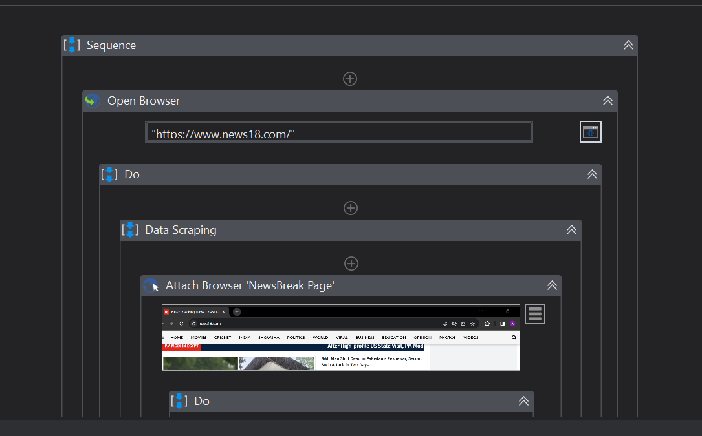

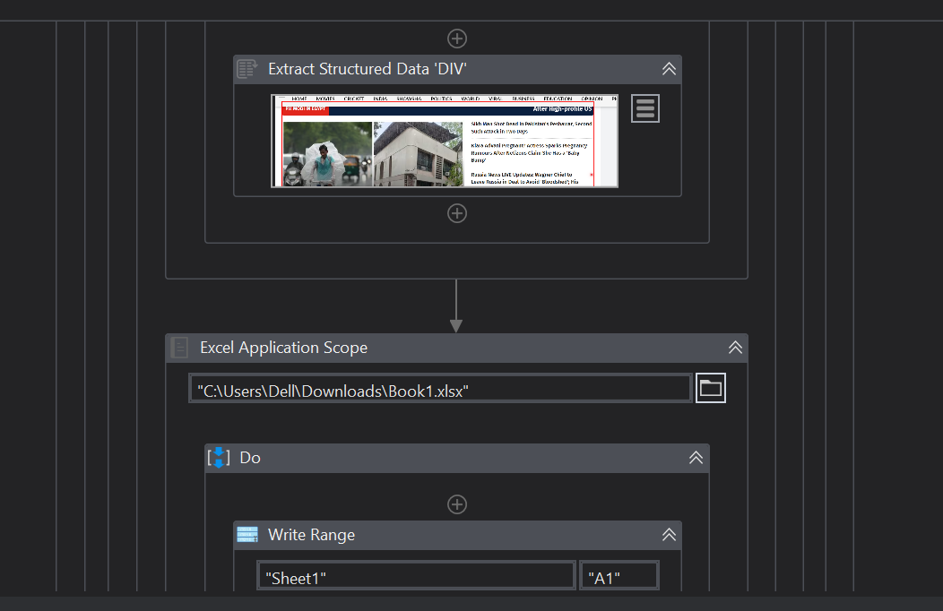

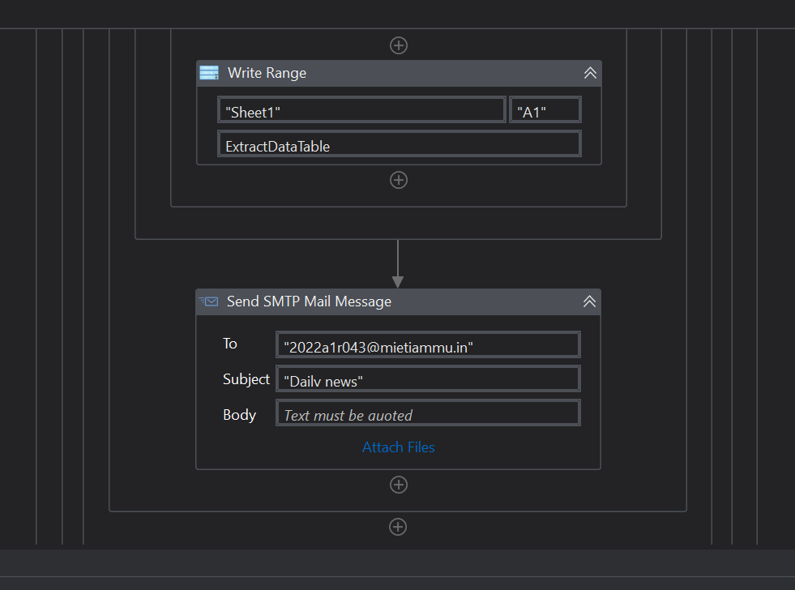

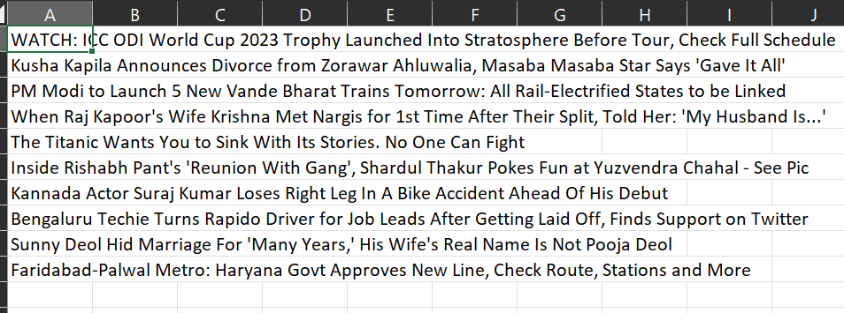

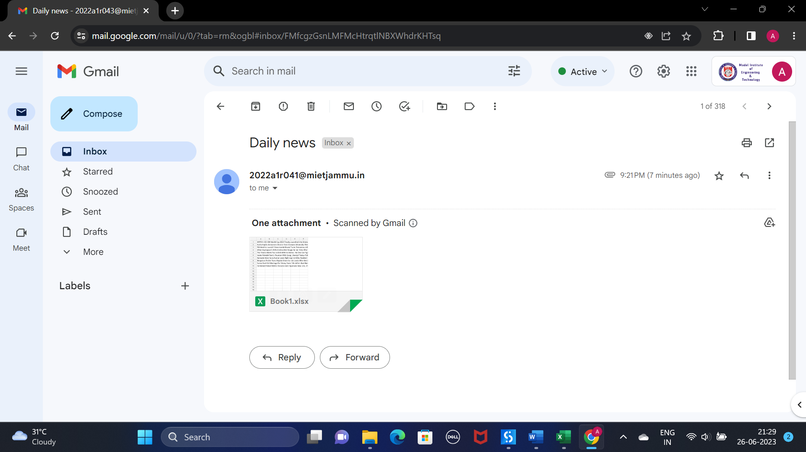

**References:**

* All the lectures taught by Ms. Vani Malgar.
* Information from Official UiPath website <https://www.uipath.com/> .
* All the practicals were performed in the Lab.
* Information gathered from Google and Youtube channels.